**SUCCESSFUL DESIGN: AUTOMOBILE SEAT ADJUSTMENT CONTROL**

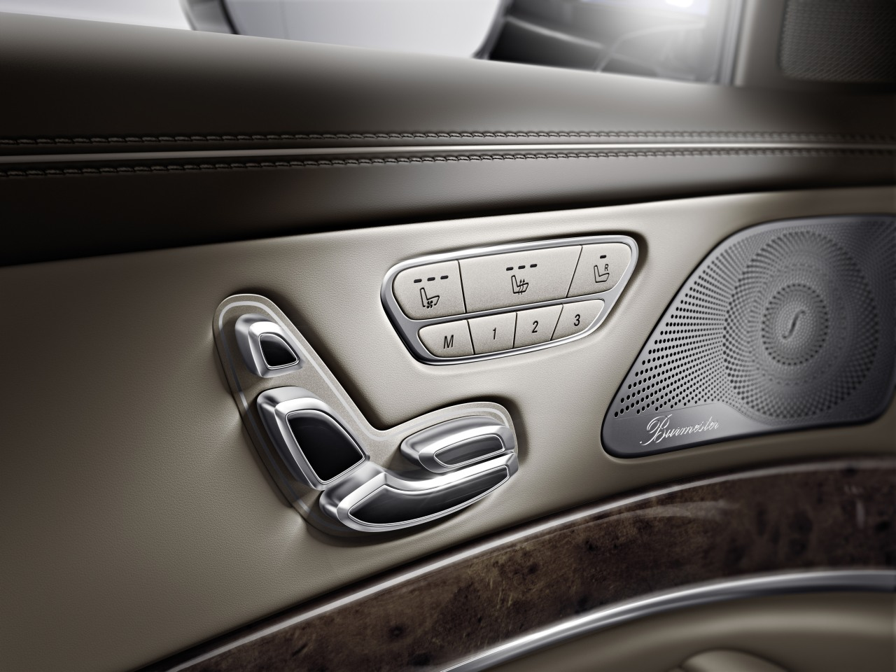

Seat adjustment control in a 2014 Mercedes-Benz S-Class.

Source: Autoblog.com

1. What system/application/product is it?

Automobile seat adjustment control is a system of switches or joysticks and small electronic motors that could be used to adjust the position of a particular seat (called power seat) on an automobile. Using this system, the power seat could be raised, tilted, brought closer or further from the steering wheel. This system has been popularized and could be found in vehicles all over the world.

1. Who is it intended for?

Automobile seat adjustment control is intended for whoever is sitting on the seat that it is connected to. The system is designed in such a way that the said person could adjust the seat to the most comfortable position. The system is minimalist in design and efficient in operation so users of all ages could use it.

1. Does it get things done?

For newer automobile models (like the photo), the system should work most of the time, unless the motors inside are broken. Older cars usually have manual control, which does not rely on motors and is not prone to electrical malfunctions.

1. What kind of use context does it have?

The system only has one use context: to adjust the position of the seat on a vehicle. This system has been modified to fit into several types of couches and armchairs, so the users could enjoy a comfortable sitting position.

1. What is its best feature?

In my personal opinion, the best feature is the ability to raise the seat effortlessly. When driving, it is necessary to maintain good visibility. A higher seat position therefore leads to a safer driving experience.

1. What are its most usable features?

From my observation, most drivers use the system to bring the seat closer or further from the steering wheel, i.e., horizontally. Tilting the back of the seat is another very usable feature. In some luxury car models, the seat could become a bed by tilting backward to the maximum allowed limit.

1. Does it make you feel good after using it?

Definitely yes. The seat adjustment control brings a whole new level of comfort and enjoyment to driving. Feeling secure and relaxed when driving makes it both safer and more fun. I have driven an old Soviet-made truck made in the 70s with fixed seat. It was unbearable as the seat raised my ankles too high.

1. What characterizes the good usability this system provides?

* Effectiveness: The system does what it is supposed to do, usually with little obstacles. The driver could seamlessly adjust the position of the seat.
* Efficiency: The system is simple enough that with minimal steps, the driver has accomplished his or her wishes regarding the seating position.
* Safety: The system has almost no risks and could do no serious harm to the users. A common error is when the driver adjusts the seat into a not desirable. This can be reversed by adjust the seating position in the opposite way.
* Utility: The system is usually simple yet contains all important functions to move the seat to a position the driver wants.
* Learnability: The configuration of components on the system is logical and easy to use. For some models, they are placed in such a way that resembles the seat itself. Some people could operate the system without initial instructions.
* Memorability: The system is very simple; therefore, forgetting how to use it is not something that occurs so frequently. Even if that happens, the user will have no problems learning how to use it again.
* Accessibility: The system is located conveniently on the door or by the side of the seat.

1. Is there still something to improve in the system in terms of user experience?

In my opinion, the automatic seat adjustment control is perfect. The system has been improved continuously since its development in the 1940s. Changes and modifications have been made to bring the system to perfection, or at least, near-perfection. In the future, further improvements such as extreme simplification of the buttons and levers are possible.